

**How Customers Are Using AI Content Marketing Agents Today**

The landscape of content marketing has undergone a **revolutionary transformation** with the adoption of AI content marketing agents. Today's marketers are leveraging sophisticated AI-powered tools and workflows to create, optimize, and distribute content at unprecedented scale and efficiency[1][2].

**Current State of AI Content Marketing Agent Adoption**

**Widespread Adoption Across Industries**

The adoption of AI content marketing agents has reached critical mass, with **87% of marketers already using AI to create content**[3]. This represents a dramatic shift from traditional content creation methods, as **90% of content marketers believe AI can enhance the performance of their content marketing strategy**[4]. The impact is substantial - companies using AI publish **47% more content each month** compared to those relying solely on manual processes[3].

**Key Performance Metrics**

Customers are experiencing tangible results from AI content marketing agents:

* **76% of businesses have had AI content ranked** at least once since adoption[5]
* Companies implementing AI marketing automation can **reduce marketing spend by up to 30%**[6]
* **77% of organizations using AI in their marketing strategy reported at least a 25% increase in revenue** within the first year[6]
* AI-powered content marketing can lead to a **60% increase in lead generation**[4]

**Current Applications of AI Content Marketing Agents**

**1. Content Creation and Optimization**

Modern AI content marketing agents excel at automating the most time-intensive aspects of content creation. **93% of marketers using AI employ it to generate content faster**, while **81% use it to uncover insights more quickly**[7]. These agents handle:

* **Blog post generation**: From initial research to SEO optimization and final drafts
* **Social media content**: Platform-specific posts, captions, and hashtags
* **Email campaigns**: Personalized newsletters and automated sequences
* **Product descriptions**: Bulk generation for e-commerce platforms
* **Video scripts and visual content**: Complete multimedia packages[8][9]

**2. Workflow Automation and Management**

Today's customers are implementing comprehensive AI workflows that connect multiple aspects of content marketing. Leading platforms like **ContentBot** and [**Copy.ai**](http://Copy.ai) offer **AI Flows** that allow users to create complex automation sequences linking triggers, actions, and filters[10][11]. These workflows can:

* Automatically generate content based on trending topics
* Schedule and publish across multiple platforms simultaneously
* Optimize content for different audiences and channels
* Track performance and adjust strategies in real-time

**3. Personalization at Scale**

AI content marketing agents enable **hyper-personalized marketing automation**[12] by:

* Creating content variations for different audience segments
* Tailoring messaging based on user behavior and preferences
* Delivering **real-time personalization** that drives conversions[13]
* Generating **content with personalized recommendations that drive 550% more interactions**[4]

**Popular AI Content Marketing Agent Platforms**

**Enterprise Solutions**

Leading enterprises are adopting comprehensive platforms such as:

* **HubSpot AI**: Integrating CRM, marketing automation, and content creation[12]
* **Jasper AI**: Offering over 90 tools for content creation with brand voice consistency[14]
* **Salesforce Agentforce**: Providing pre-built solutions for marketing functions[15]

**Mid-Market and SME Solutions**

Smaller organizations are gravitating toward:

* **ContentShake AI**: Creating SEO-focused articles 12x faster[14]
* [**Writer.com**](http://Writer.com): Speeding up content production by 50-70% while ensuring compliance[14]
* **Surfer SEO**: Combining SERP analysis and NLP for content optimization[14]

**Specialized Workflow Platforms**

Many customers are building custom solutions using:

* **Zapier**: For automating workflows between different marketing tools[16]
* [**Make.com**](http://Make.com): For creating complex multi-step automation sequences[17]
* **Airtable AI**: For managing content pipelines and collaboration[16]

**The Earlier Process: Traditional Content Marketing Challenges**

**Manual Content Creation Timeline**

Before AI adoption, content marketing was characterized by **labor-intensive processes** that demanded significant time investments. A typical content creation workflow involved[18][19]:

**Traditional Blog Post Creation (1,000-1,500 words):**

* Research phase: 2-3 hours
* Writing and drafting: 3-4 hours
* Editing and optimization: 1-2 hours
* **Total time: 6-9 hours per post**

**Social Media Content:**

* Idea generation and writing: 30-60 minutes per post
* Design and formatting: Additional 15-30 minutes
* Platform optimization: 10-15 minutes

**Email Campaigns:**

* Strategy and copywriting: 2-4 hours
* Design and personalization: 1-2 hours
* Testing and deployment: 30-60 minutes

**Traditional Workflow Limitations**

**Resource-Intensive Operations**

The traditional content marketing process faced several critical challenges[20][21]:

1. **Consistency Issues**: Maintaining regular publishing schedules was difficult due to manual bottlenecks
2. **Scalability Problems**: Growth was limited by team capacity and manual processes
3. **Quality Control**: Human error and inconsistent execution impacted content effectiveness
4. **Time Allocation**: Teams spent excessive time on repetitive tasks rather than strategic initiatives

**Content Research and Planning Challenges**

Traditional content teams struggled with[22]:

* **Information Gathering**: Scouring public domain sources was extremely time-consuming
* **Competitor Analysis**: Manual research of competitor content and performance metrics
* **Keyword Research**: Using separate tools for SEO optimization and content planning
* **Topic Ideation**: Brainstorming sessions that often yielded limited creative output

**Workflow Management Problems**

Before automation, content teams dealt with[23][24]:

* **Fragmented Systems**: Using multiple disconnected tools for planning, creation, and distribution
* **Communication Gaps**: Unclear handoffs between team members and stakeholders
* **Approval Bottlenecks**: Manual review processes that delayed publication
* **Performance Tracking**: Difficulty measuring ROI and content effectiveness across channels

**The New Process: AI-Powered Content Marketing Transformation**

**Streamlined AI Workflow Architecture**

The modern AI-powered content marketing process represents a **paradigm shift** from manual operations to intelligent automation[25][26]. Today's workflow typically follows this streamlined approach:

**AI-Enhanced Content Creation Process:**

1. **AI-Powered Research and Ideation** (Minutes vs. Hours)
   * Automated topic discovery using trend analysis
   * Competitor content gap identification
   * SEO keyword research and optimization suggestions
   * Real-time data integration from multiple sources[27][28]
2. **Intelligent Content Generation** (20 minutes vs. 6-9 hours)
   * AI drafting based on optimized briefs
   * Brand voice consistency through machine learning
   * Multi-format content creation (blog, social, email simultaneously)
   * Automated fact-checking and source citation[29][27]
3. **Automated Optimization and Distribution**
   * Platform-specific formatting and optimization
   * Multi-channel publishing with scheduling
   * A/B testing automation for performance optimization
   * Real-time performance tracking and adjustments[9][28]

**Time and Efficiency Improvements**

**Dramatic Time Reduction**

The transformation from traditional to AI-powered processes has yielded remarkable efficiency gains:

* **Content creation time reduced by 50-80%** across most content types[30][19]
* **Blog post creation**: From 6-9 hours to 2-4 hours (including human oversight)
* **Social media content**: From 30-60 minutes to 5-10 minutes per post
* **Email campaigns**: From 2-4 hours to 30-60 minutes for complete campaigns

**Real-World Implementation Examples**

A content creator using the new AI-powered approach reports[29]:

"Prior to AI, I performed manual research to draft a comprehensive outline, conducted keyword research using a separate tool, then spent an ample amount of time drafting the content... This entire process took me about eight hours total. Now, with the help of AI, this entire process only takes me four hours total."

**Advanced AI Workflow Systems**

**Comprehensive Automation Platforms**

Modern customers are implementing sophisticated AI workflow systems that handle end-to-end content operations[8][11]:

**AI Flows and Automation Sequences:**

* **Trigger-based content creation**: Automatically generate content based on trending topics, calendar events, or performance metrics
* **Multi-step workflow automation**: Connect ideation, creation, optimization, and distribution in seamless sequences
* **Conditional logic implementation**: Route content through appropriate channels based on type, audience, or performance criteria

**Integration Capabilities:**

* **CRM synchronization**: Align content creation with sales and customer data
* **Multi-platform publishing**: Simultaneously distribute optimized content across 7+ platforms
* **Performance analytics integration**: Real-time optimization based on engagement metrics[31][28]

**Quality and Consistency Improvements**

**Enhanced Content Quality Control**

Contrary to concerns about AI-generated content quality, modern implementations show significant improvements:

* **79% of businesses report an increase in content quality thanks to AI**[32]
* **Only 4% of companies publish unedited, "pure" AI content**[3]
* **80% of organizations manually review AI-generated outputs** before publication[3]

**Brand Consistency and Compliance**

AI content marketing agents now excel at maintaining brand voice and compliance requirements[14]:

* **Brand voice learning**: AI systems adapt to company-specific tone and messaging
* **Compliance checking**: Automated review for regulatory and brand guideline adherence
* **Multi-language consistency**: Maintaining brand voice across different languages and markets

**Cost-Effectiveness and ROI**

**Resource Optimization**

The new AI-powered approach delivers substantial cost benefits:

* **Marketing spend reduction of up to 30%** through enhanced efficiency[6]
* **70% increase in ROI** for marketers using AI tools[32]
* **Reduced need for large content teams** while maintaining or increasing output quality and volume

**Strategic Resource Reallocation**

With AI handling repetitive tasks, marketing teams can now focus on:

* **Strategic planning and campaign development**
* **Creative ideation and brand storytelling**
* **Performance analysis and optimization**
* **Customer relationship building and engagement**

The transformation from traditional to AI-powered content marketing represents one of the most significant productivity advances in modern marketing. By automating time-intensive manual processes while enhancing quality and consistency, AI content marketing agents have fundamentally changed how businesses approach content creation and distribution, delivering measurable improvements in efficiency, cost-effectiveness, and marketing performance.

**Multi-Agent Pattern for AI Content Marketing Agents**

**Overview**  
Implement a collaborative AI system by decomposing the content marketing workflow into specialized, communicating agents coordinated by a supervisor agent.

**1. Supervisor Agent**

* Task decomposition & orchestration
* Routes requests to specialized agents
* Consolidates outputs into final deliverable

**2. Specialized Agents**

|  |  |
| --- | --- |
| Agent Role | Responsibility |
| Research Agent | Gathers market trends, keyword data, competitor insights[1] |
| Planner Agent | Builds content outline, SEO structure, publishing schedule |
| Writer Agent | Drafts blog posts, social media copy, email campaigns |
| Editor Agent | Proofreads, enforces brand voice and compliance |
| Optimizer Agent | Performs SEO tuning, A/B testing, performance analytics[2] |

**3. Orchestration Pattern**

* **Router/Supervisor**: hierarchical delegation for controlled workflow[2]
* **Sequential Flow**: predictable pipeline (Research → Plan → Write → Edit → Optimize)
* **Feedback Loops**: real-time performance data informs subsequent agent tasks[3]

**Benefits**

* **Scalability**: parallel execution of independent tasks
* **Specialization**: each agent leverages tailored prompts & tools
* **Efficiency**: end-to-end automation reduces creation time by 50–80%
* **Quality & Consistency**: centralized supervision ensures brand alignment

*References:*  
[2] Amazon Bedrock multi-agent collaboration preview[2]  
[1] Vellum multi-agent content creation example[1]  
[3] DZone multi-agent architecture components[3]

⁂

**Personalized Product-Launch Marketing Agent: Multi-Agent Pattern**

**Key Takeaway:** Orchestrate a suite of specialized AI agents to deliver hyper-personalized campaigns—boosting engagement, conversion, and ROI for your new product launch.

**1. Supervisor Agent**

Coordinates the campaign pipeline, routes tasks to specialized agents, enforces brand guidelines, and consolidates final deliverables.

**2. Specialized Agents**

|  |  |
| --- | --- |
| **Agent Role** | **Responsibility** |
| Audience Segmentation | Analyzes CRM, web, and purchase data to create dynamic customer cohorts with shared attributes. |
| Offer Personalization | Generates tailored value propositions and promotional copy per segment/individual. |
| Content Creator | Drafts multi-format assets (emails, social posts, landing pages) aligned to segment profiles. |
| Channel Scheduler | Selects optimal send times and channels (email, SMS, push, social) for each cohort. |
| Performance Analyst | Monitors engagement metrics, runs A/B tests, and feeds real-time insights back to other agents. |

**3. Orchestration & Feedback**

* **Sequential Flow:**
  1. Segmentation → 2. Offer Personalization → 3. Content Creation → 4. Scheduling → 5. Analysis
* **Parallelization:** Multiple cohorts process concurrently for scale.
* **Feedback Loops:** Performance Analyst informs Offer and Content agents to refine messaging mid-campaign.

**4. Benefits**

* **True Personalization at Scale:** 1:Many and 1:1 tailored experiences without manual overhead.
* **Agility & Adaptability:** Real-time optimizations based on live engagement data.
* **Consistency & Brand Alignment:** Supervisor agent enforces tone, compliance, and KPI targets.
* **Resource Efficiency:** Automated workflows free teams to focus on strategic planning.

*Implement this multi-agent architecture to launch products with pinpoint personalization—driving higher open rates, click-throughs, and conversions.*

⁂

**Personalized Product-Launch Marketing Agent (One-Slide Summary)**

**Orchestrate Specialized AI Agents for Hyper-Personalized Product Launch Campaigns**

* Supervisor Agent  
  – Coordinates pipeline, enforces brand guidelines, consolidates deliverables
* Audience Segmentation Agent  
  – Builds dynamic customer cohorts from CRM, web & purchase data
* Offer Personalization Agent  
  – Generates tailored value props & promo copy per segment
* Content Creation Agent  
  – Drafts emails, social posts & landing pages aligned to segments
* Channel Scheduling Agent  
  – Optimizes send times & channels (email, SMS, push, social)
* Performance Analysis Agent  
  – Monitors metrics, runs A/B tests & feeds insights back

**Workflow & Feedback Loops**  
Segmentation → Personalization → Creation → Scheduling → Analysis  
(real-time insights refine messaging mid-campaign)

**Key Benefits**

* True personalization at scale
* Agility through real-time optimization
* Brand consistency via centralized supervision
* Efficiency—teams focus on strategy, not execution

**visual diagram**

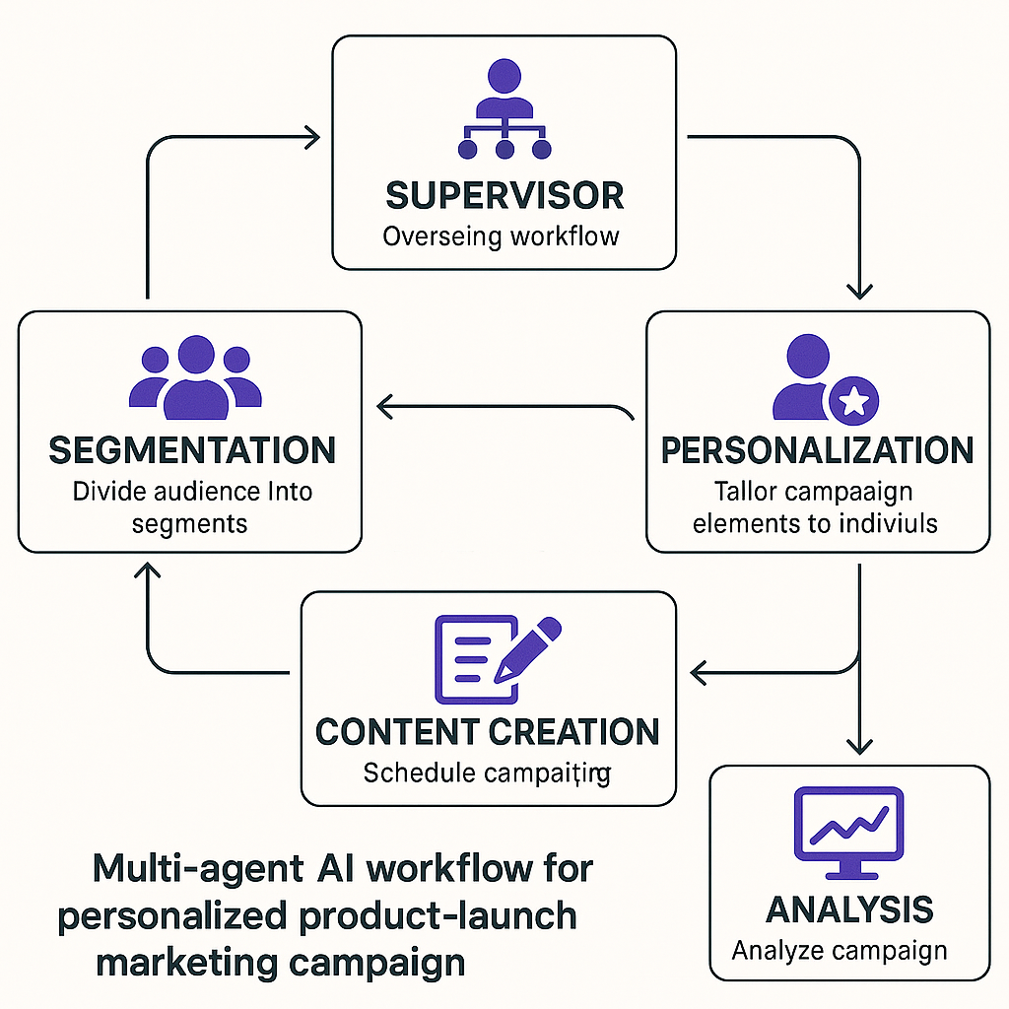

Multi-agent AI workflow diagram for personalized product launch marketing

**Personalized Product-Launch Marketing Agent Interaction Diagram**

This flowchart illustrates the collaboration and information flow between the Supervisor Agent and specialized agents in a personalized product-launch marketing campaign.

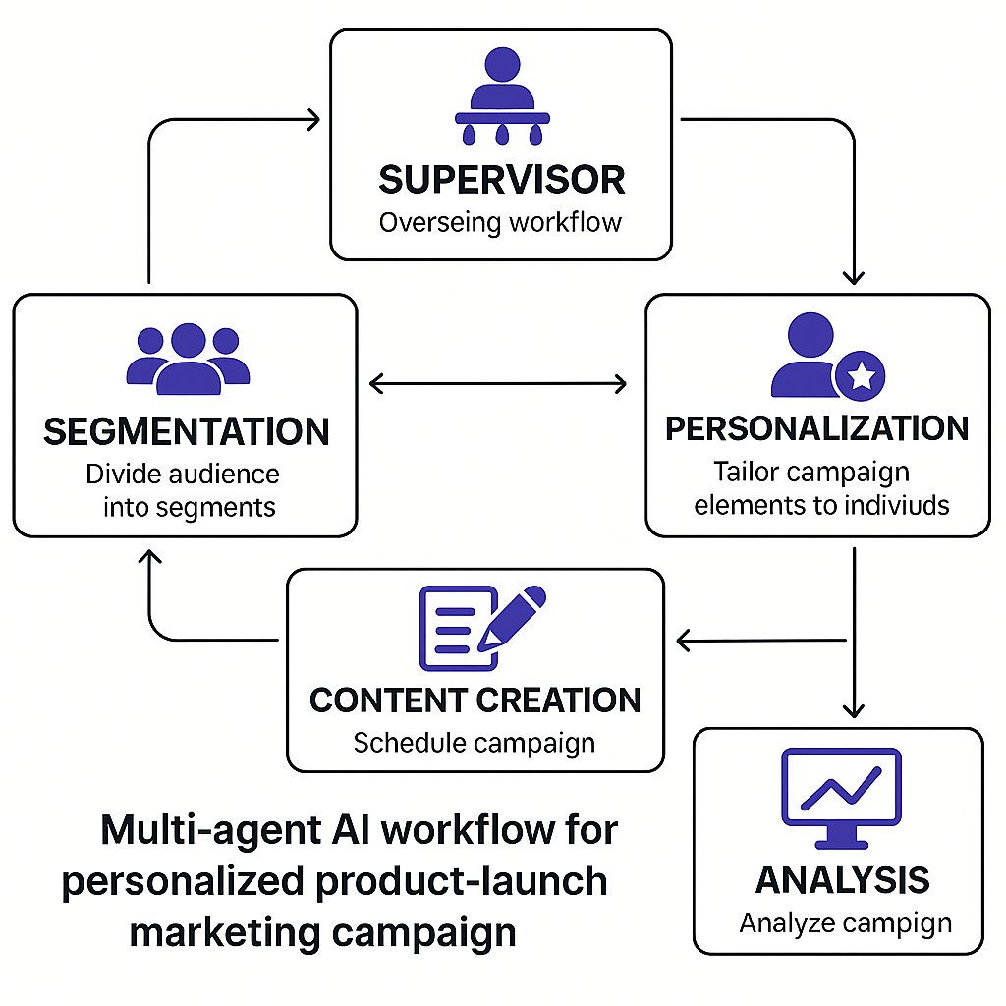

Flowchart of multi-agent workflow for personalized product-launch marketing campaign

1. <https://docs.vellum.ai/product/workflows/examples/multi-agent-chatbot>

1. <https://aws.amazon.com/blogs/aws/introducing-multi-agent-collaboration-capability-for-amazon-bedrock/>

1. <https://dzone.com/articles/multi-agent-systems-architecture?fromrel=true>